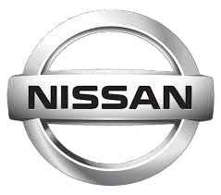


GSO Conformity Certificate CCR No. 567398
Motor Vehicles
Manufacturer: NISSAN MOTOR CO., LTD.
Country of Origin: SOUTH AFRICA, Country of Production: SOUTH AFRICA
To: GCC Standardization Organization (GSO)
We hereby certify that the vehicles manufactured by NISSAN MOTOR CO., LTD.
* Type: Nissan Navara D23 2.5L Pick-Up 4x2 4Doors
* VlN number: ADNCAND23Z0049798
* Model Year: 2025 * Produced in and after: Month 07 Year 2025
* Category: Truck
Will satisfy the G50 Technical Regulations Nos: 34:20o7, 3s:2007, 36:2005, 37:2012, 38:200s, 392005, 40:2011,42:2015, 48:1984, 51:20o7, 52:2007, 53.2007, 9611988. 9721988, 9811988, 9921988,13522007, 13622007. 29021994. 4119:1994,42o:1994,421:2005,422:200s.1040:20001041:2000,1042:2000,1053:2000,1503:2010,1598:2002,1624:2002,1677:2003,1708:2o0s,1780:2010,1781:2006,1782:2008,1783:2006,1784:2o0e.Gsolso1585:2008,GSO lSO 3537:2008, GSO 150 3538:1997, G50 ECE13H:2012,GSO ECE13H-1:2012,GSO ECE13H-2:2012,GSO ECE 13H-3:2012, GSO ECE13H-4:20l2, GSO ECE13H-S:2012,GSO ECE 13H-6:2012 and the standards in the country of origin accepted by GSO in the case that no GSO technical regulations and standards are available.
All the essential technical data are as follows:
1. Weights
a. Maximum Vehicle Weight: 3035 kg b. Curb: 2100 kg
c. Maximum Axle Weight: Front: 1490 kg Rear: 1545 kg
2. Dimensions
a. Length: 5260 mm b. Width: 1875 mm
c. Height: 1850 mm d. Wheelbase (Fl R1) 3150 mm e. Track: Front: 1570 mm Rear: 1570 mm
3. Type of chassis and body: Body-on-frame
4. Number of Passengers: 5(Including the Driver)
5.Engine: Petrol a. Cylinders: 4 b. Displacement: 2488cc c. Air intake: Naturally Aspirated
d. Net Engine Power: 118 kW at 6000 rpm Pollutant Limit comply with Euro 5.
6. Transmission: Manual

7. Brakes a. Service Brakes: Hydraulic b. Emergency Brakes: Combined with the service brake
8. Fuel Economy a. Motor Vehicle Class: Light Truck b. FE (CAFE) Combined: 12.3 km/L - Good
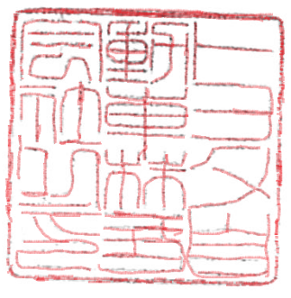
9. Any other information or local standards to be compiled: Also comply with the National regulations for member countries mentioned in the Annex of the list of Technical Regulations for MV 2026 MY-D5, when exporting to those countries
Keiko Yanagi
general Manager Regulation &Certiﬁcation Division
20 OCT 2025 20252025

